**Topics: Descriptive Statistics and Probability**

1. Look at the data given below. Plot the data, find the outliers and find out $μ, σ, σ^{2}$

|  |  |
| --- | --- |
| **Name of company** | **Measure X** |
| Allied Signal | 24.23% |
| Bankers Trust | 25.53% |
| General Mills | 25.41% |
| ITT Industries | 24.14% |
| J.P.Morgan & Co. | 29.62% |
| Lehman Brothers | 28.25% |
| Marriott | 25.81% |
| MCI | 24.39% |
| Merrill Lynch | 40.26% |
| Microsoft | 32.95% |
| Morgan Stanley | 91.36% |
| Sun Microsystems | 25.99% |
| Travelers | 39.42% |
| US Airways | 26.71% |
| Warner-Lambert | 35.00% |

Ans: $μ$ = 33.271333

$σ$ = 16.945401

$σ^{2}=$ 287.1466123809524

This data set has one outlier which is Morgan Stanley which is at 91.36

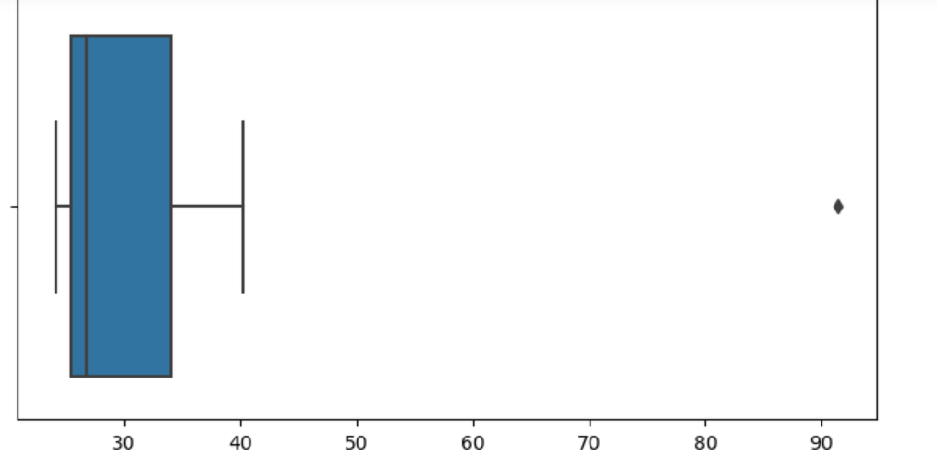



Answer the following three questions based on the box-plot above.

1. What is inter-quartile range of this dataset? (please approximate the numbers) In one line, explain what this value implies.
2. What can we say about the skewness of this dataset?
3. If it was found that the data point with the value 25 is actually 2.5, how would the new box-plot be affected?

Ans:

1. The inter-quartile range of this dataset is Q3 – Q1 ie 12.5 – 5 = 7.5

This implies it covers more than 50% of the data

2) By the box plot we can say that the it positively skewed of this data set

3) If the data point with the value 25 is actually 2.5 the new box plot would be slightly

Different. The lower whisker of the box plot would extend to this new value



Answer the following three questions based on the histogram above.

1. Where would the mode of this dataset lie?
2. Comment on the skewness of the dataset.

IT is positively skewed

1. Suppose that the above histogram and the box-plot in question 2 are plotted for the same dataset. Explain how these graphs complement each other in providing information about any dataset.

Ans: 1)The mode of this dataset would be around 5 to 6 as the frequency of this value is highest in this dataset

2) The data is positively skewed dataset

3) In the histogram we can find out the data set is positively skewed or negatively skewed

Uniformily distributed but in the boxplot we can easily find the outliers and remove them so that the mean of the dataset is not disturbed

1. AT&T was running commercials in 1990 aimed at luring back customers who had switched to one of the other long-distance phone service providers. One such commercial shows a businessman trying to reach Phoenix and mistakenly getting Fiji, where a half-naked native on a beach responds incomprehensibly in Polynesian. When asked about this advertisement, AT&T admitted that the portrayed incident did not actually take place but added that this was an enactment of something that “could happen.” Suppose that one in 200 long-distance telephone calls is misdirected. What is the probability that at least one in five attempted telephone calls reaches the wrong number? (Assume independence of attempts.)

Ans: Probability of at least one misdirected call=1−(1−0.005)5≈0.0245

1. Returns on a certain business venture, to the nearest $1,000, are known to follow the following probability distribution

|  |  |
| --- | --- |
| x | P(x) |
| -2,000 | 0.1 |
| -1,000 | 0.1 |
| 0 | 0.2 |
| 1000 | 0.2 |
| 2000 | 0.3 |
| 3000 | 0.1 |

1. What is the most likely monetary outcome of the business venture?
2. Is the venture likely to be successful? Explain
3. What is the long-term average earning of business ventures of this kind? Explain
4. What is the good measure of the risk involved in a venture of this kind? Compute this measure

Ans) 1) The most likely monetary outcome of this business venture is which has highest probability. From the above question, we can say that the x has the highest probability of 0.3 with $2000

2) to determine if the venture is likely to be successful, we need to assess whether the expected value of the returns is positive

*E*=−200−100+0+200+600+300=800

3) The long-term average earning is equivalent to the expected value, which we have already calculated as $800. This represents the average earnings over the long term for business ventures of this kind

4) *σ*=14400+4000+128000+8000+108000+484000​=758400​≈871.82

This indicates the level of risk associated with this venture.